**The SK Salon (website)**

**User’s Manual**

**for IT Support Services**

Prepared by: Haley Hardwick and

Ben Wanagat

**Revision Sheet**

|  |  |  |
| --- | --- | --- |
| **Release No.** | **Date** | **Revision Description** |
| Rev. 0 | 4/17/17 | User’s Manual Created |
|  |  |  |
|  |  |  |
|  |  |  |
|  |  |  |
|  |  |  |

**USER’S MANUAL**

**TABLE OF CONTENTS**

Page #

***1.0*** ***GENERAL INFORMATION***

**1.1** **Purpose 1**

***2.0*** ***WEBSITE NAVIGATION 2-1***

**2.1** **The SK Salon (Home page) 2-2**

**2.2 About, Services, Stylists, Products 2-3**

**2.3** **Photo Gallery 2-4**

**2.4** **Contact 2-5**

***3.0 ADMINISTRATIVE PORTAL* 3-1**

**3.1** **Log-In 3-2**

**3.2** **Admin 3-3**

**3.2.1 Logo 3-3**

**3.2.2 Admin Users 3-4**

**3.3** **Home 3-5**

**3.3.1 Home: New Content 3-5**

**3.3.2 Home: Edit/Delete Content 3-6**

**3.4** **About, Services, Stylists, Products 3-7**

**3.4.1 About, Services, Stylists, Products: New Content 3-7**

**3.4.2 About, Services, Stylists, Products: Edit/Delete Content 3-8**

**3.5** **Photos 3-9**

**3.6** **Inventory: Main Page 3-10**

**3.6.1 Scanning Items 3-11**

**3.6.2 Customers 3-14**

**3.6.3 Inventory Management 3-18**

**3.6.4 Reports 3-24**

**3.7** **Admin and Passwords 3-26**

**1.0 GENERAL INFORMATION**

**GENERAL INFORMATION**

**1.1** **Purpose**

The purpose of this manual is to show the user(s) how to navigate and utilize both the front and backend of The SK Salon website.

**2.0 WEBSITE NAVIGATION**

**WEBSITE NAVIGATION**

The following displays the websites main navigation bar located at the top of this screen and all subsequent pages. The tabs on the navigation bar are as follows:

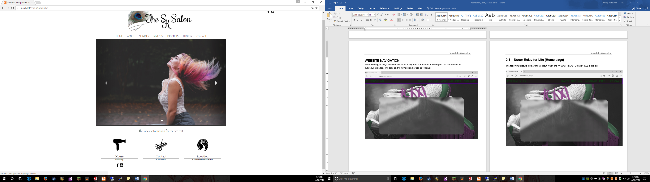

**2.1 The SK Salon (Home page)**

The following picture displays the site’s home page with test data inserted:

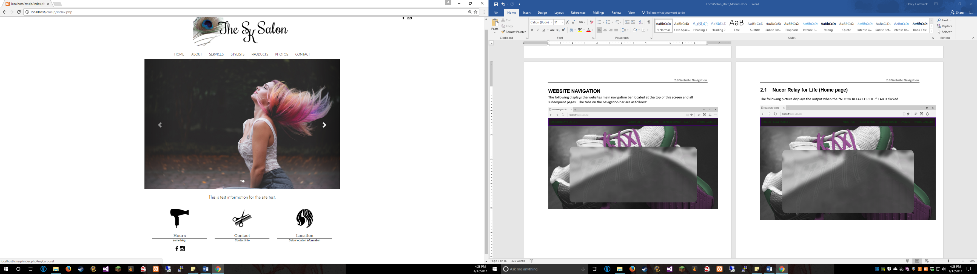

**2.2 About, Services, Stylists, and Products**

The following picture displays a sample of the styling for each of the listed pages. Each of these pages is laid out in a grid pattern consist throughout the About, Services, Stylists, and Products pages.

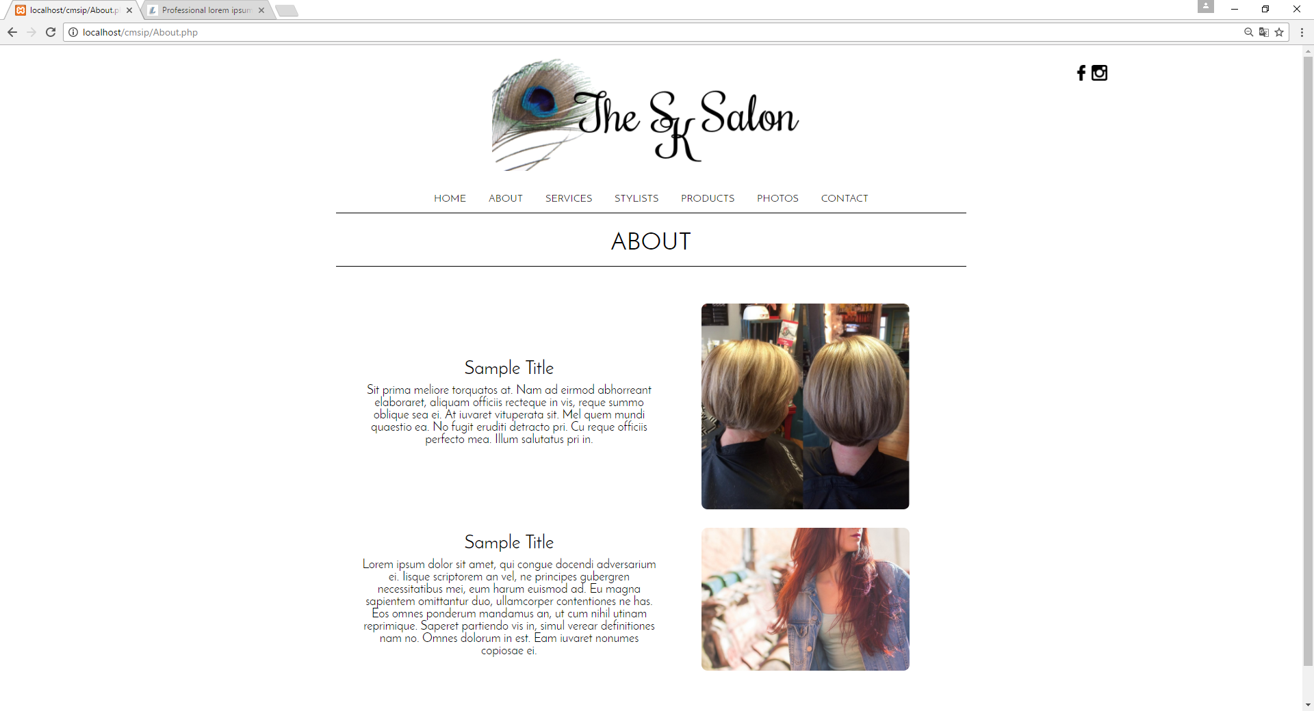

**2.3** **Photo Gallery**

The following picture displays the photo gallery, which was laid out in a three-column grid pattern. The photo gallery contains a light box, which allows the user to click a picture to display it full size and navigate through the pictures using the buttons.

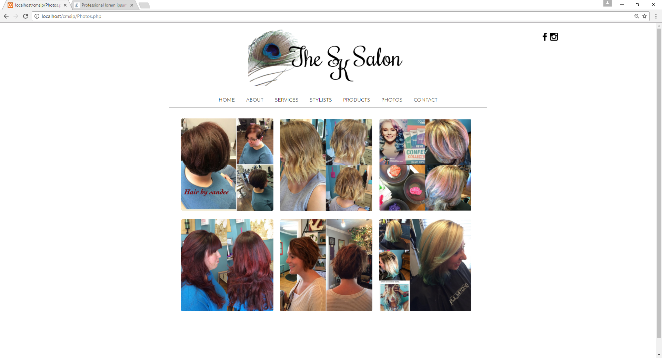

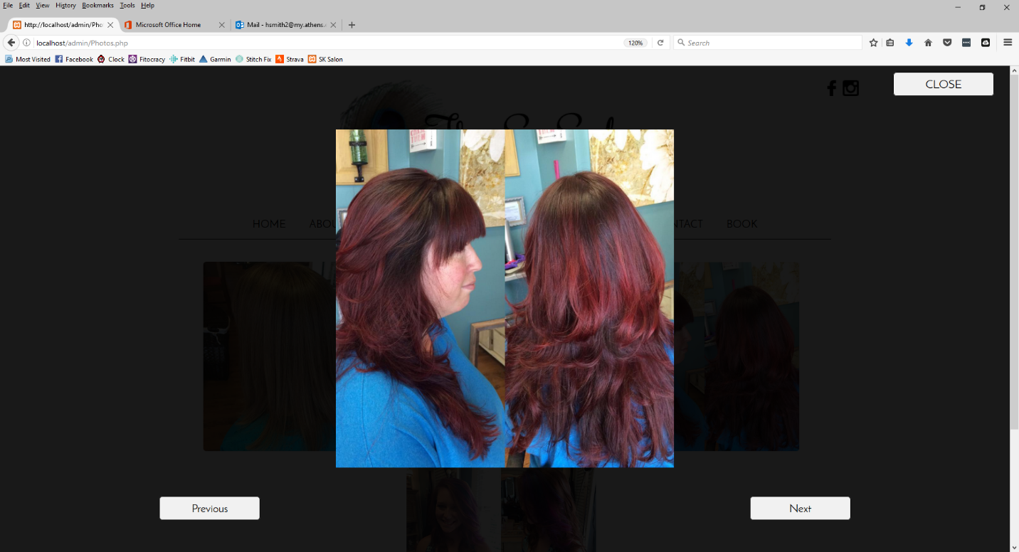

**2.4 Contact**

The following picture displays the contact page’s form allowing users to interact with The SK Salon as well as get a map of the salon’s location.

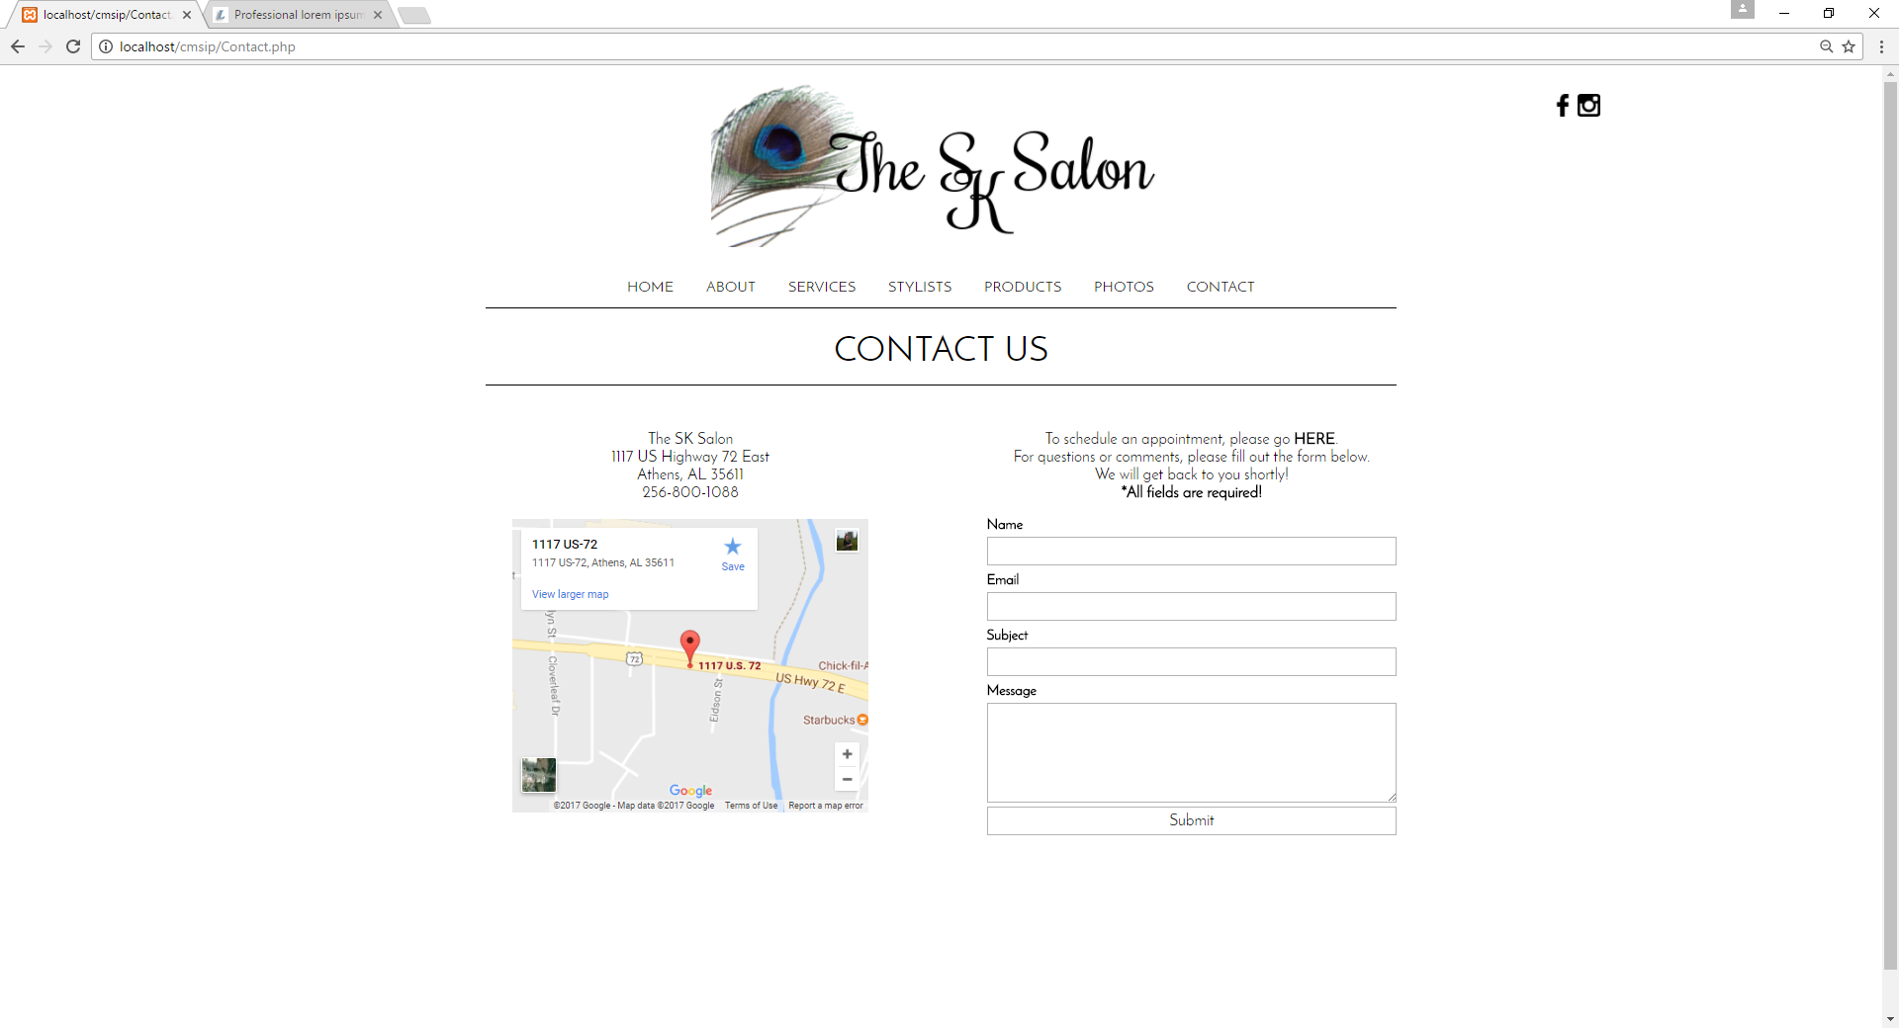

**3.0 ADMINISTRATIVE PORTAL**

**3.1 Administrative Portal: Logging In**

To log in to the administrative portal, navigate to the following page: Then log in with the administrator account information. This information has been set for you. (**Username**: admin **Password**: 1234)

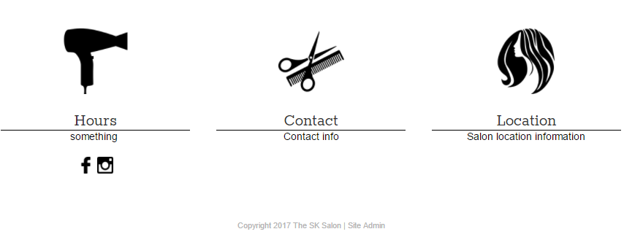

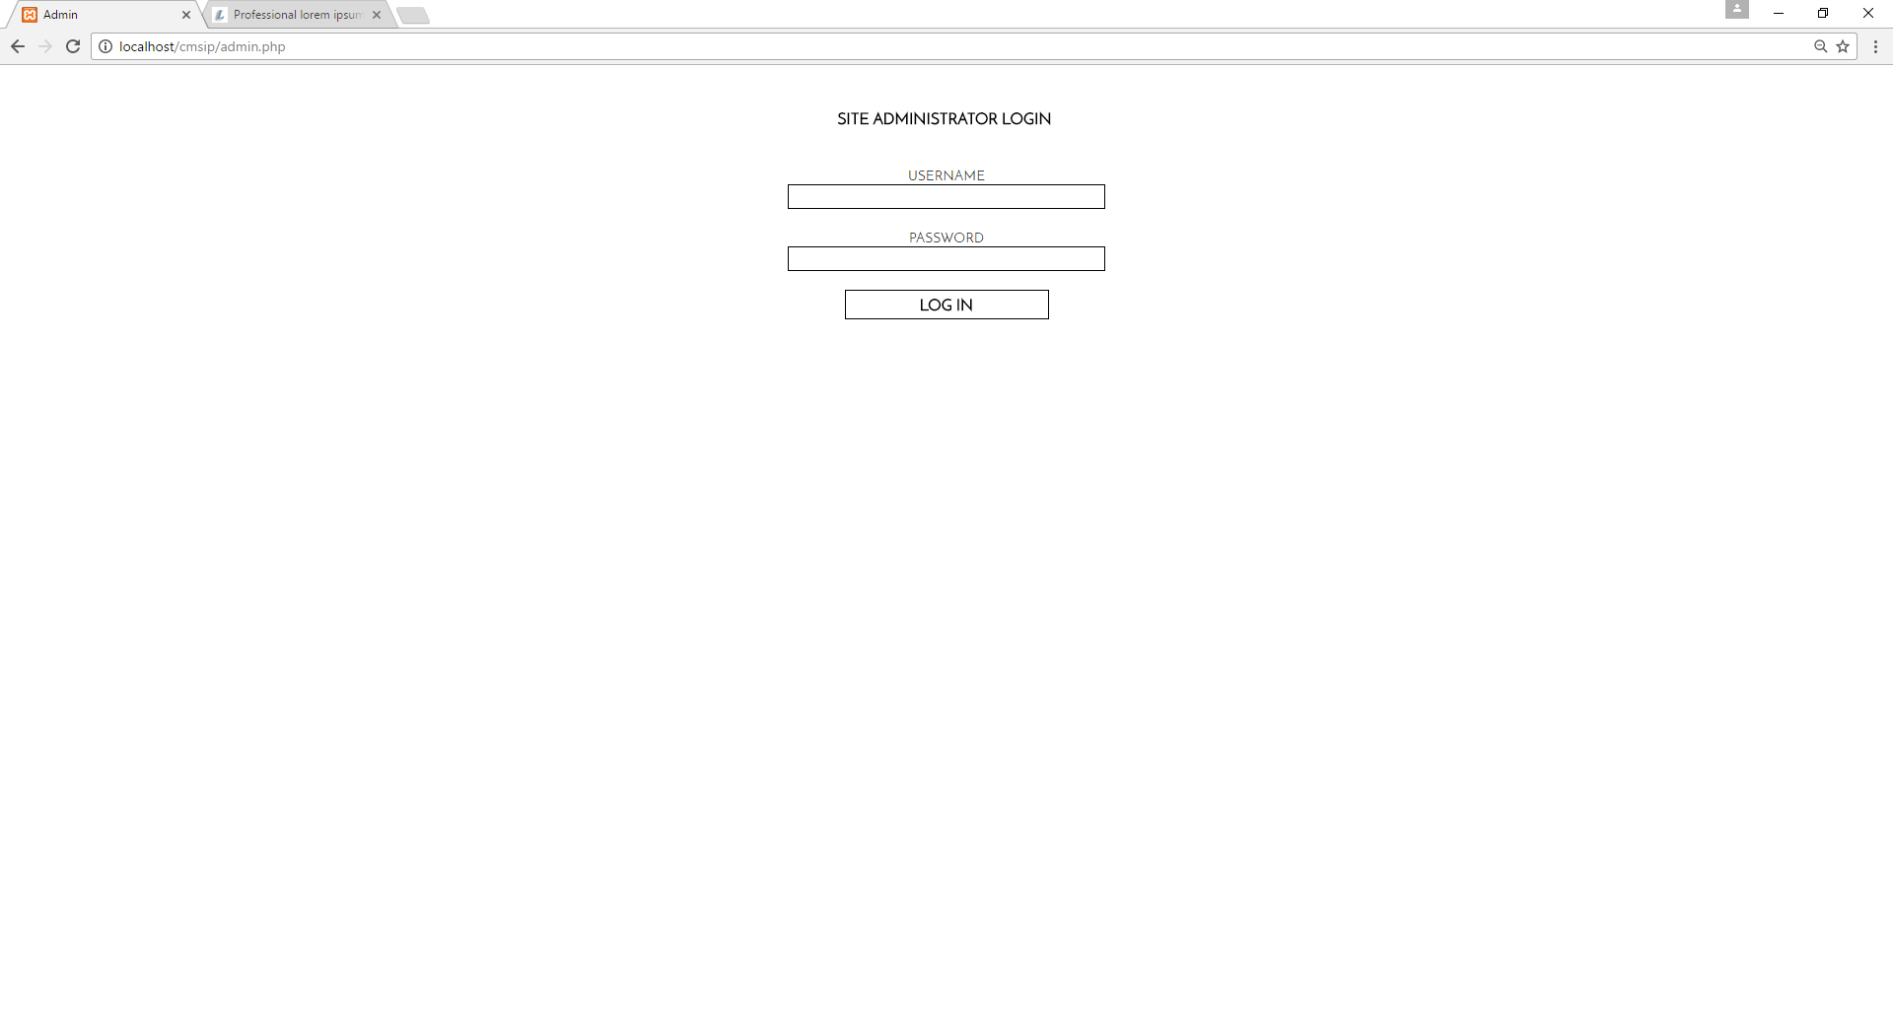

**3.2.1 Admin Page: Site Logo**

The Admin page is the first page of the administrative portal. It contains places to change the website’s logo as well as a place to add new users to the administrative portal. To choose a new logo, click Choose File under the All Pages tab and select your image file. Click Update.

To add a new user or view current users, select either View Users to view all administrative users, or Add New User to create a new user for the administrative portal.

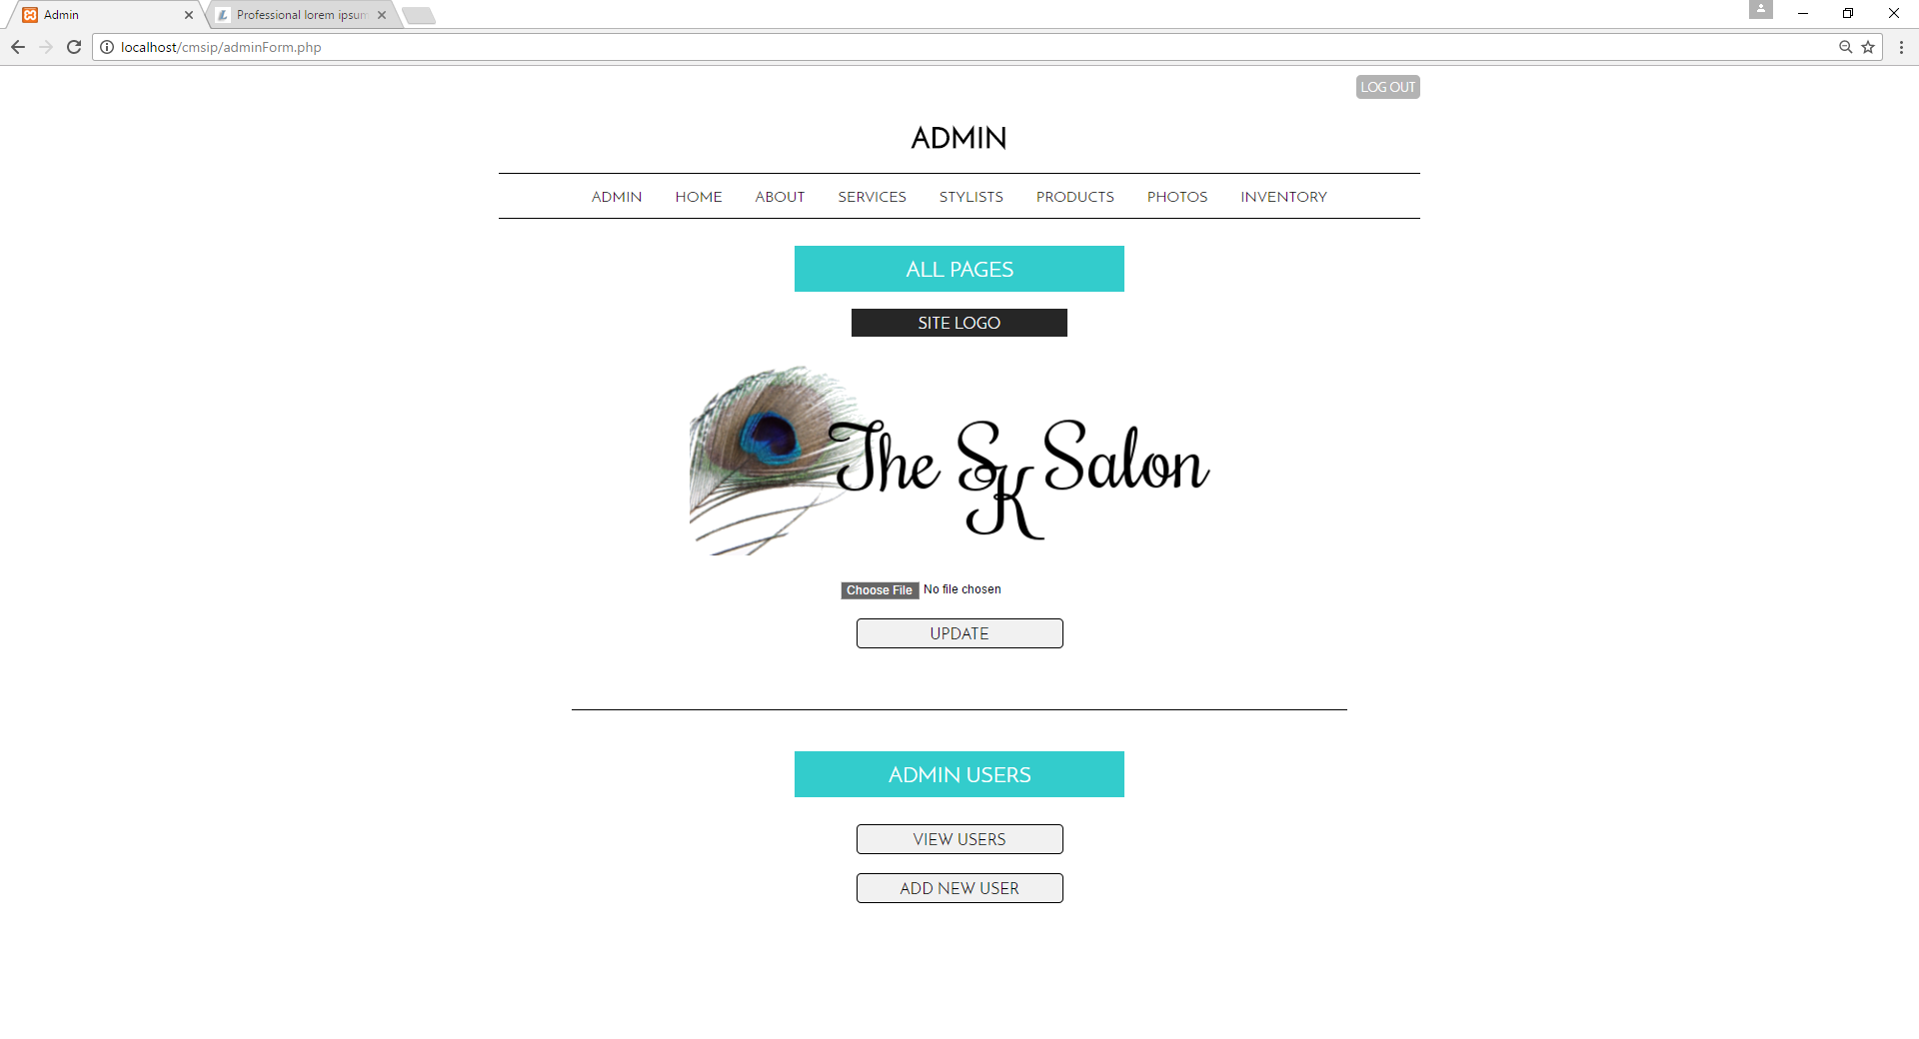

**3.2.2 Admin Page: Admin Users**

To add a new user or view current users, select either View Users to view all administrative users (or Edit or Delete user information), or Add New User to create a new user for the administrative portal.

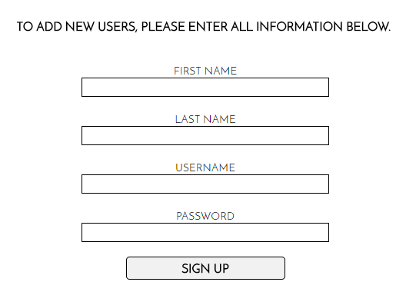 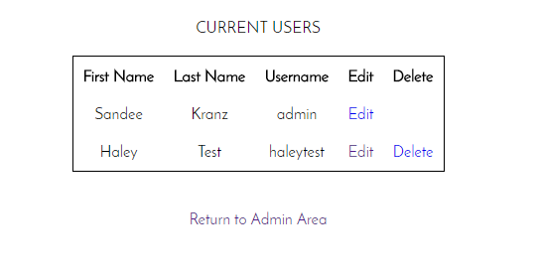

**3.3.1 Home: New Content**

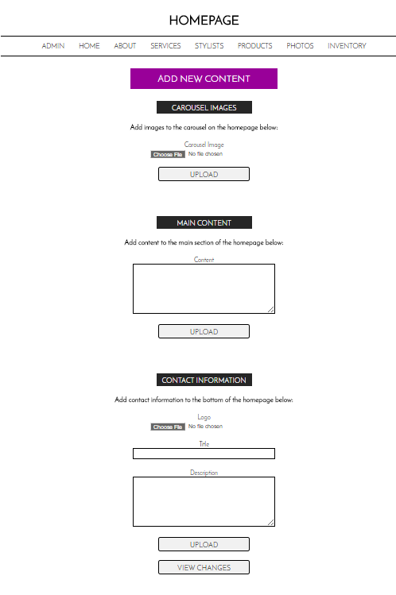The Home tab will allow you to create new content for your first page or edit any information currently displayed on your home page. To Add new content, look under the Add New Content heading and update as appropriate. You can include new carousel images, main text, or blocks for the bottom of the website by looking for the appropriate subheadings. Don’t forget to click the upload buttons to save changes. To view your work, select View Changes.

Subheadings are labeled in **black**.

Insert new content with the text boxes or choose image files by clicking **Choose File.**

Click **View Changes** to see how your new content looks on the page!

Don’t forget to click **Upload** when you’ve finished your new content!!

**3.3.2 Home: Edit/Delete Content**

The Edit Current Content heading will allow you to edit or delete content for the home page. To edit, simply edit the text or select choose file to change images. When you’ve made your selections, click Update. To delete an item, find the delete button underneath the content your wish to delete.

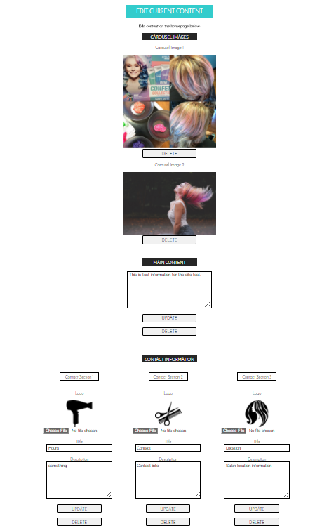

Click **Update** to save your changes or **Delete** to get rid of the block entirely.

Click **Choose File** to update an image. Simply alter the text in the text box as needed.

Click **Delete** underneath any item you wish to delete.

**3.4.1 About, Services, Stylists, Products: New Content**

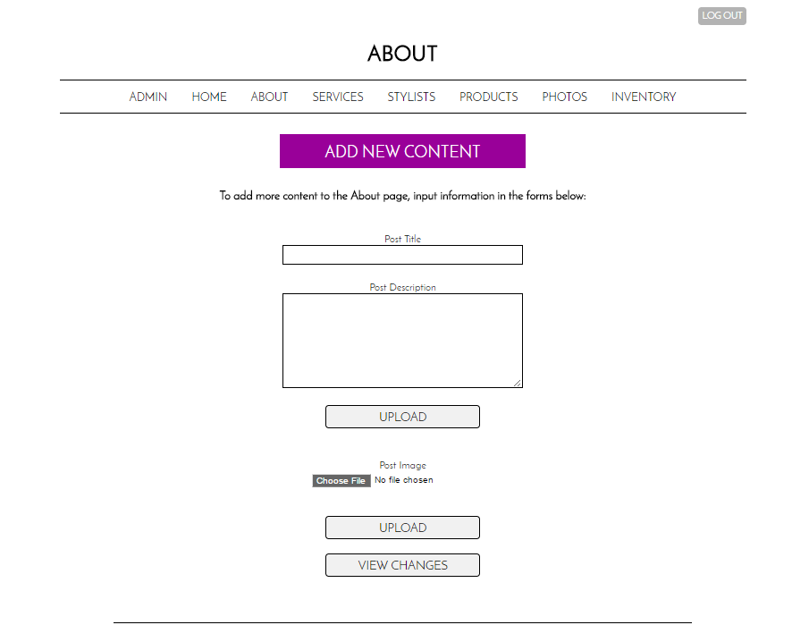The following directions are pertinent to the About, Services, Stylists, and Products pages. To add new content, look under the **Add New Content** heading and update as appropriate. You can include new images or text by looking for the appropriate subheadings. Don’t forget to click the upload buttons to save changes. To view your work, select View Changes.

Don’t forget to click **Upload** when you’ve finished your new content!!

Click **View Changes** to see how your new content looks on the page!

Insert new content with the text boxes or choose image files by clicking **Choose File.**

**3.4.2 About, Services, Stylists, Products: Edit/Delete Content**

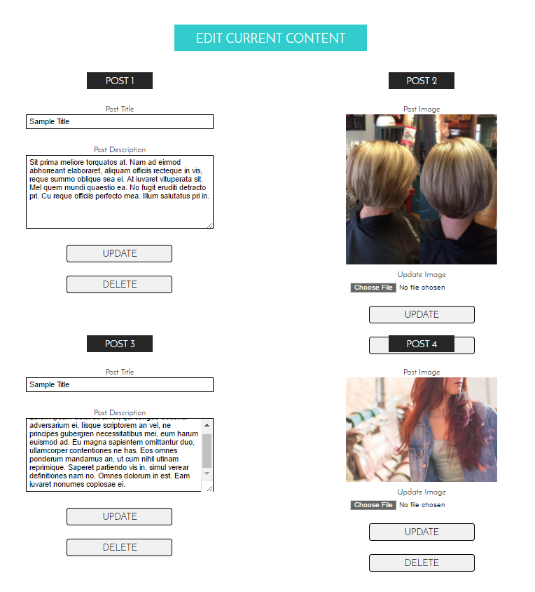The following directions are pertinent to the About, Services, Stylists, and Products pages. To edit or delete content, scroll down until you see **Edit Current Content**.

Click **Delete** underneath any item you wish to delete.

Click **Update** to save your changes or **Delete** to get rid of the block entirely.

**3.5.1 Photos**

The photo gallery can be amended at any time by either adding new content or delete old content. These photos will appear in the grid structure on the Photos page.

Click **View Changes** to see how your new content looks on the page!

Don’t forget to click **Upload** when you’ve finished your new content!!

Insert new content with the text boxes or choose image files by clicking **Choose File.**

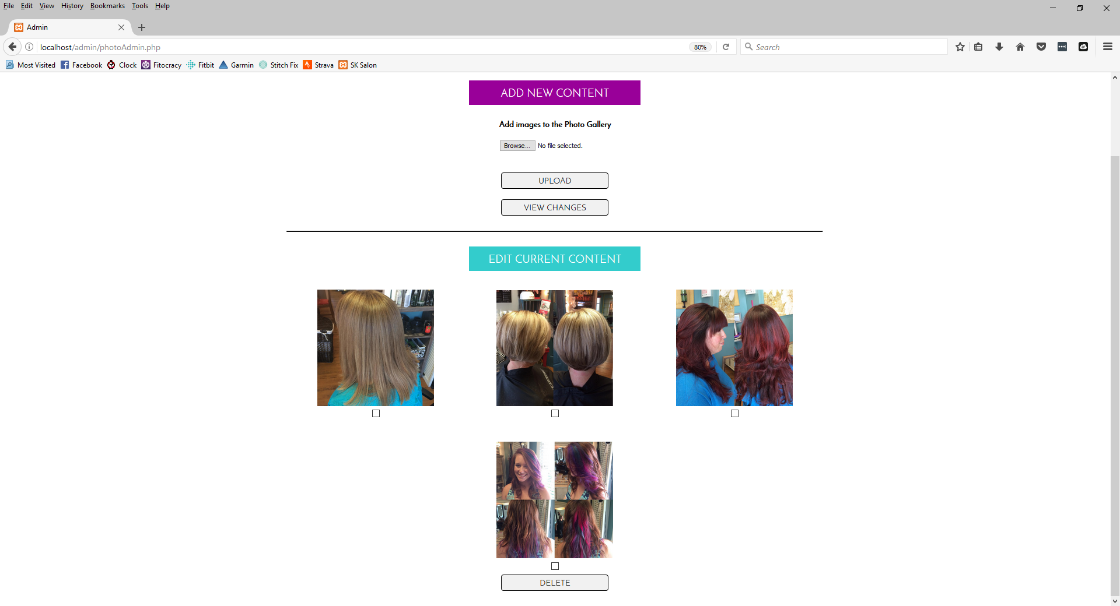

**3.6 Inventory: Main Page**

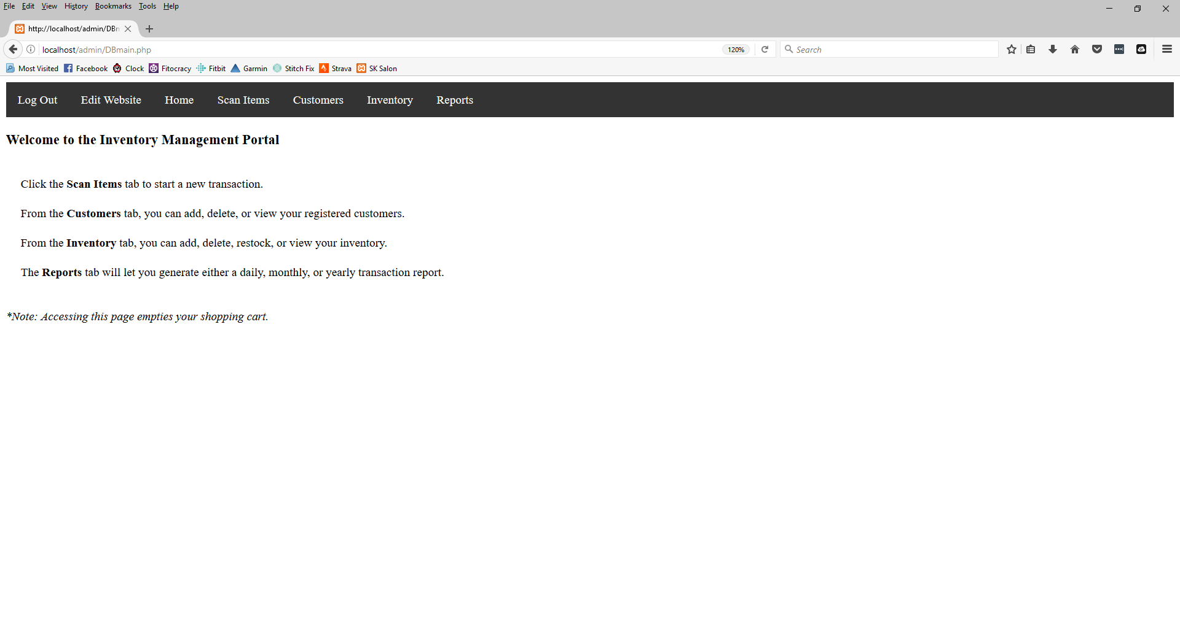The main inventory page has its own navigational menu, seen in black below. From this menu, you can logout, return to editing the website, return home (to this screen below), scan items for checkout, manage customers, manage inventory, or view reports.

**3.6.1 Inventory: Scanning Items**

**Scan Items Page - Bar Code Scanner**

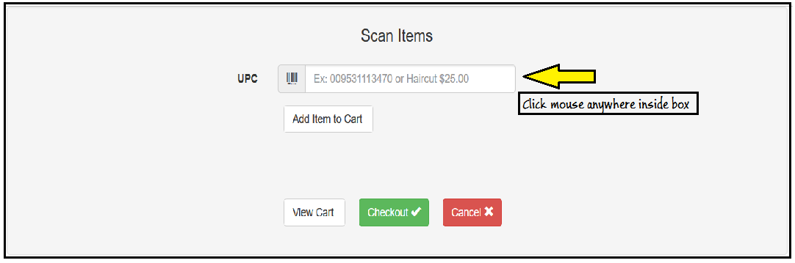

1) Mouse click inside UPC box

2) Take scan gun and scan bar code of product

3) This will automatically add item to shopping cart

4) If there are more items repeat steps 1 through 3 until no more items to scan.

5) If nothing else to add go to checkout -(checkout explained later)

**Scan Items Page - Enter Bar code manually**



1) Mouse click inside UPC box

2) Type in bar code of product

3) Click Add Item to Cart - to add item to shopping cart

4) If there are more items repeat steps 1 through 3 until no more items to enter.

5) If nothing else to add go to checkout -(checkout explained later)

**Scan Items Page - Enter Non-Bar Items**



1) Mouse click inside UPC box

2) Type in name of item/service, ie "Hair Cut"

3) type in $,then type in amount

4) Click Add Item to Cart - to add item to shopping cart

5) If there are more items repeat steps 1 through 3 until no more items to enter.

6) If nothing else to add go to checkout -(checkout explained later)

**Scan Items Page - Checkout**

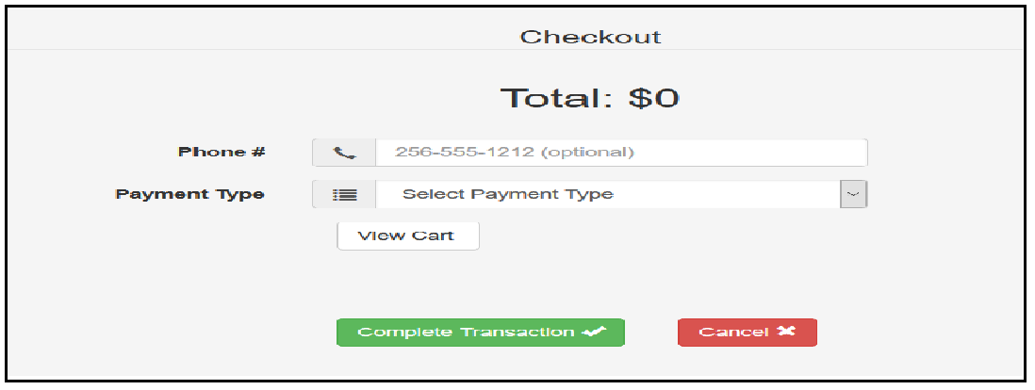

1) On this page it will have the orders total

2) Enter the phone number of the customer*

*This must be the same phone number that was entered when the customer was added to the database

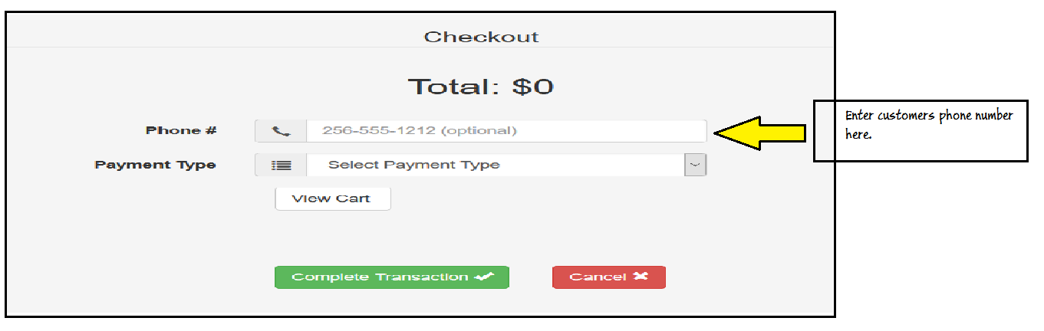

3)Click on Drop down box for payment type

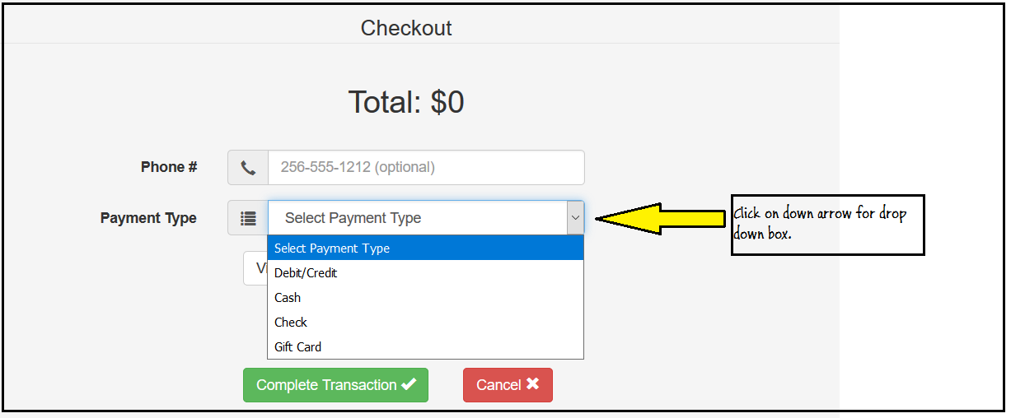

Once payment type has been selected you can either view cart or, complete transaction or cancel transaction.

If you select Complete Transaction, this is the time that you run the payment on your Point of Sale system. The Complete Transaction button on this system logs the information into the system to be able to create reports and to keep inventory up to date.

**3.6.2 Inventory: Customers**

**Customers tab - View All Customers**

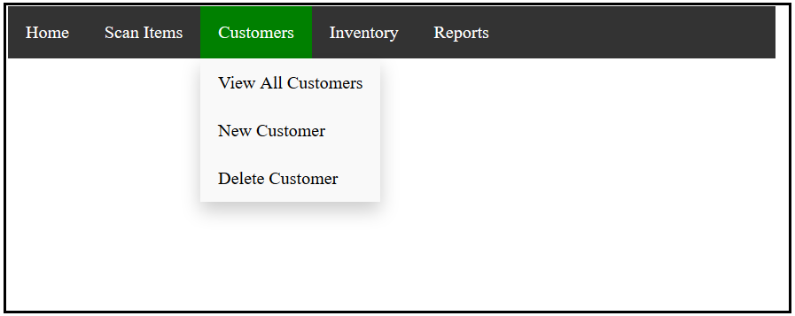

1)To view all customers added into the system click on View All Customers

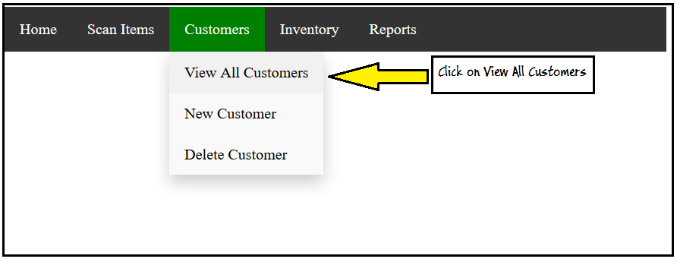

The screen that is returned displays all customers in the system that have been added.

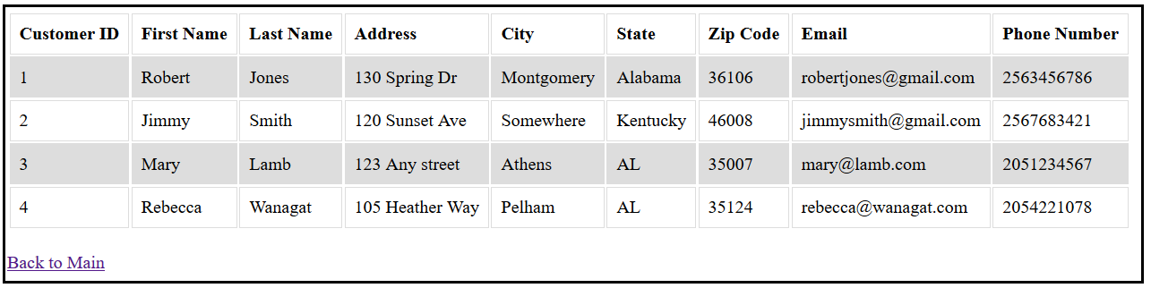

Click on Back to Main, to return to the main data base page

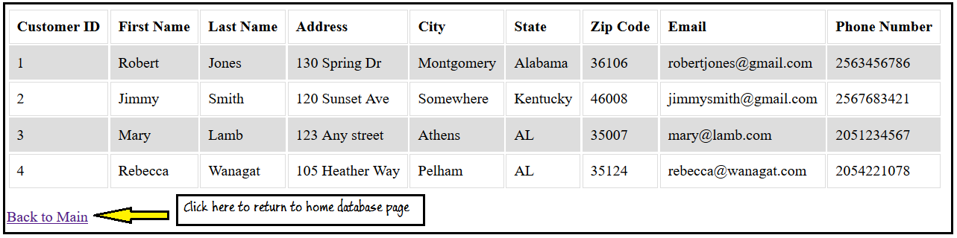

**Customers tab - New Customer**

Click on New Customer to Add a new customer to the database

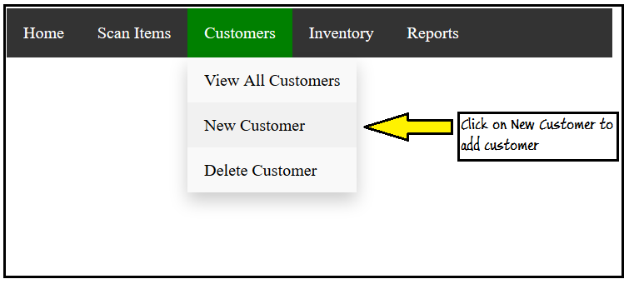

Fill in all fields.

The system will check for any errors in formatting and will tell you the field that needs to be fixed

Then Click Send to send information to the database

The phone number entered will be the phone number used when entering a transaction

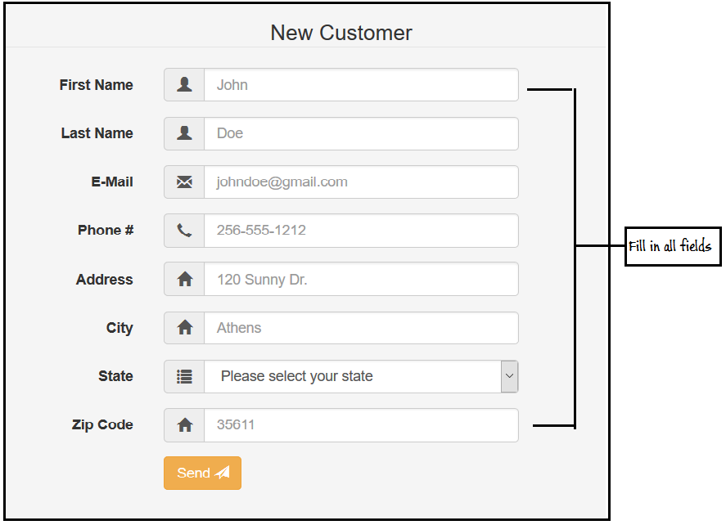

**Customers tab - Delete Customer**

Click on Delete Customer to delete a customer from the database

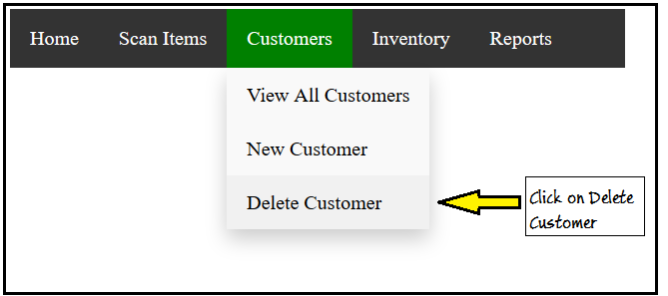

Enter information and press Delete.

This will remove the client from the database

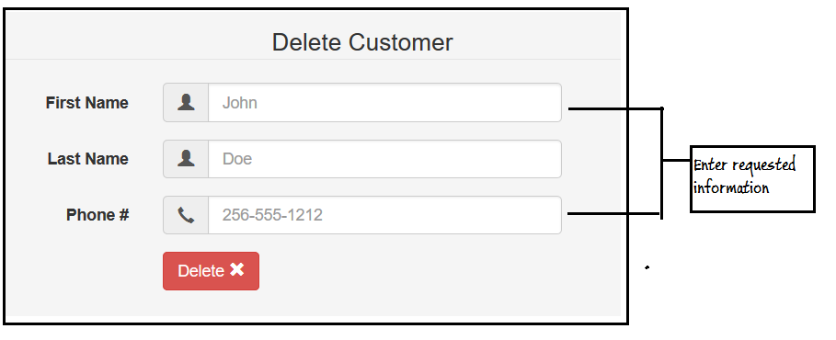

**3.6.3 Inventory: Inventory Management**

**Inventory**

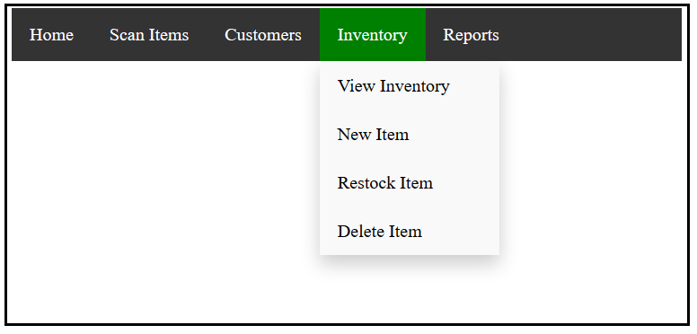

**View all Inventory**

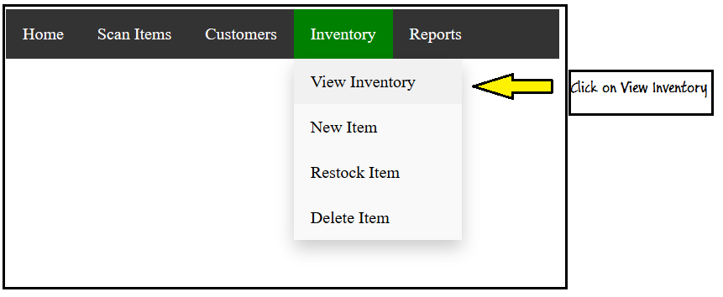

This will show complete inventory listing

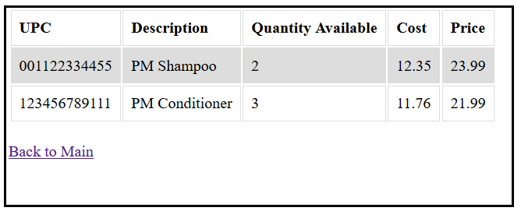

To go back to the Home database screen click on Back to Main

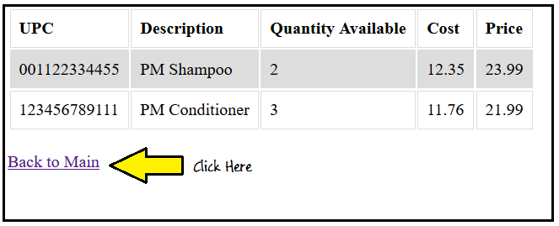

**Add New Item to Inventory**

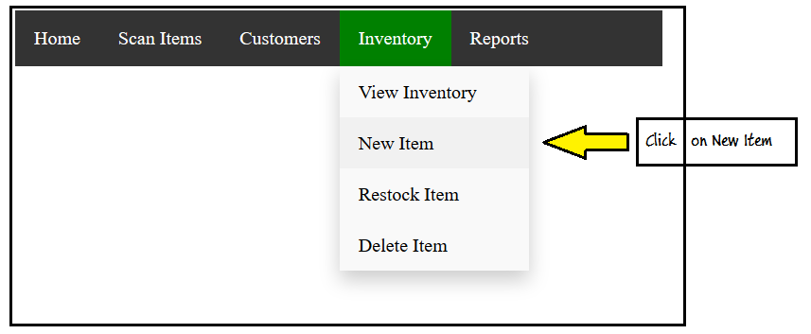

Enter the requested information for the new item

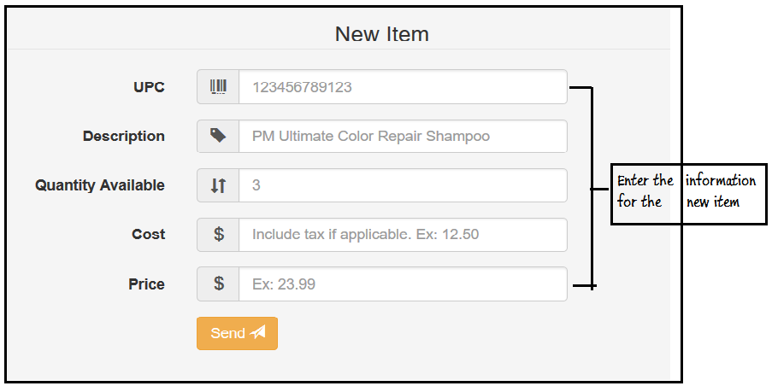

Click Send to send information to the database

The system will check for any errors in formatting and will tell you the field that needs to be fixed

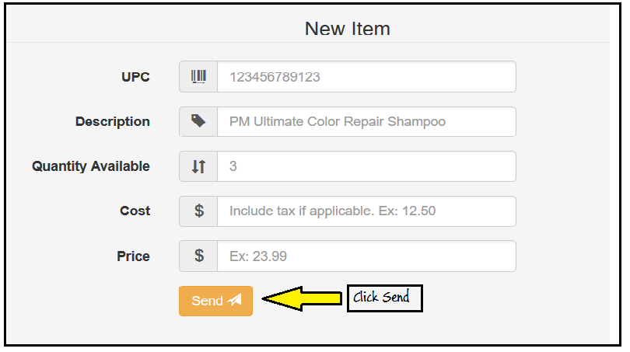

**Restock Item in Inventory**

This allows the user to add the number of items received

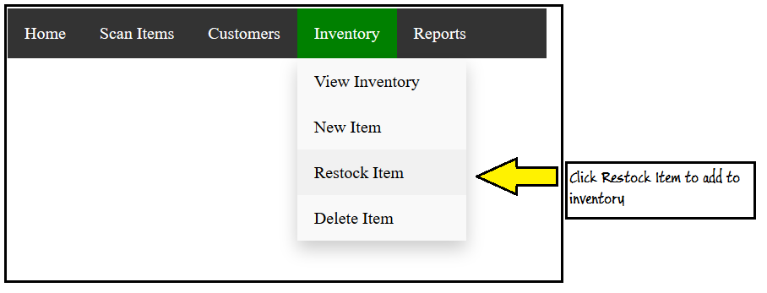

Scan or type in upc

Enter the amount received, not on hand quatity

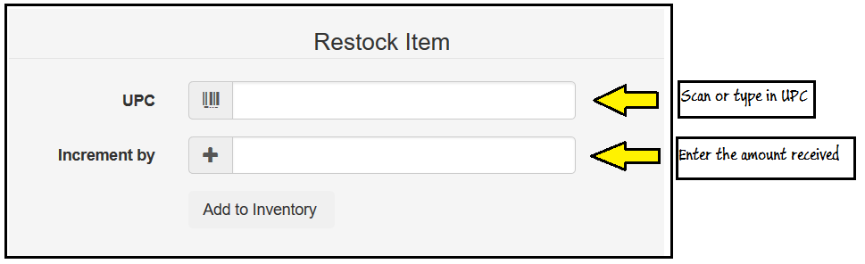

Click Add to Inventory to update quantity in inventory

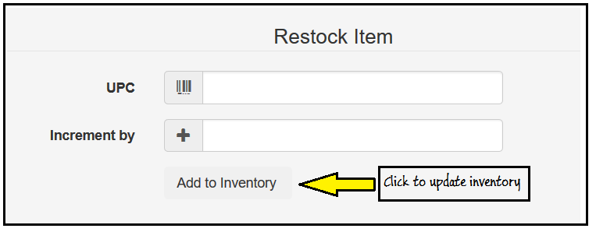

**Delete Item from Inventory**

This allows the user to remove an item from inventory

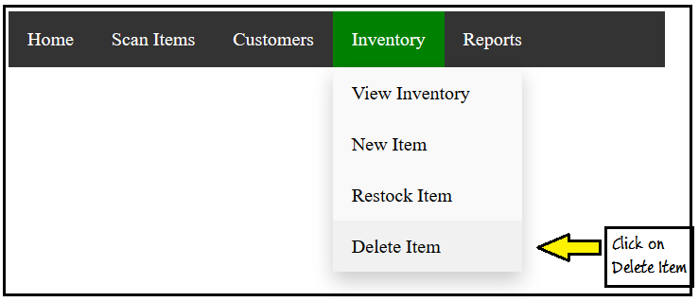

Enter UPC information.

Either by scanning or typing in number manually

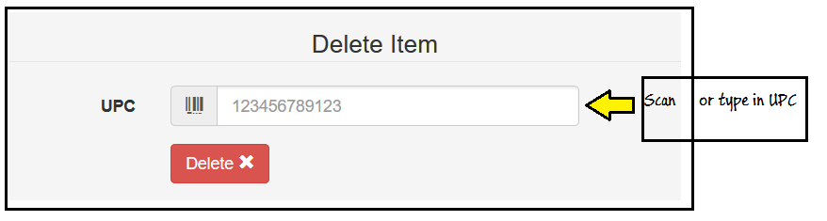

Click on Delete to remove item from database

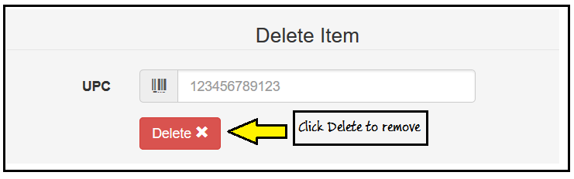

**3.6.4 Inventory: Reports**

Reports

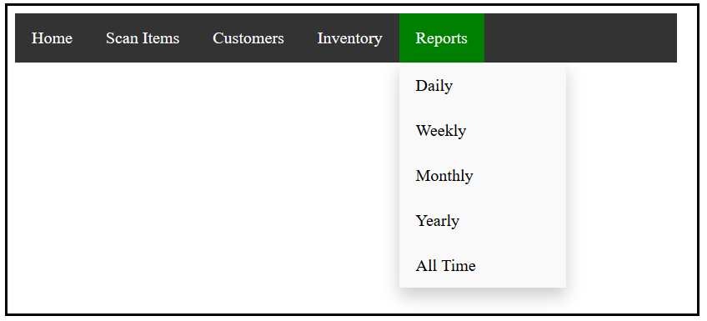

All reports display the data in the same layout on screen.

The only difference in the amount of time for each report

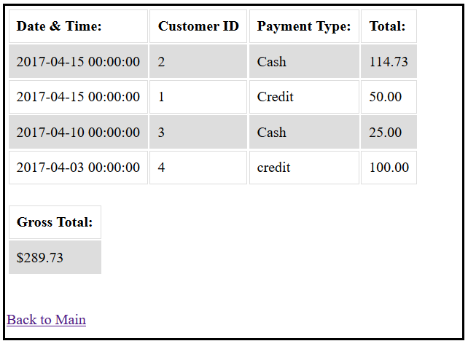

To return to the Home Database page click on Back to Main

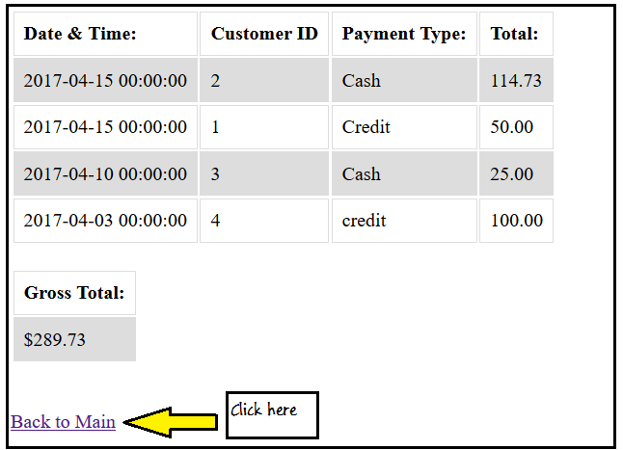

**3.7 Administrative Information and Passwords**

All relevant information about logging in to your new website is included in this section.

**Web Address:** thesksalon.com

**GoDaddy:** <https://sso.godaddy.com/>

Username: sandeeandcompany@gmail.com

Password: Thesksalon1

Support Pin: 0217

**Site Admin:** <webaddress goes here>

Username: admin

Password: